Phishing alert button

Add-in for Microsoft Outlook

Contents

Abstract 2

Introduction 2

Requirements Analysis 3

Design 3

Implementation 4

User Guide 4

Technical Handover Guide 7

Languages / Formats Used Within This Project 7

Build Process 7

Current Source 7

Running And Implementing 8

Conclusion 9

References 10

Appendices 10

# Abstract

Phishing emails are something that we have come to expect, however; as these scams have come more sophisticated, they can become difficult to spot, and this can have devastating consequences on businesses.

This project creates an outlook add-in that will allow users to access a reporting page, users can report emails that they suspect to be phishing attacks, these emails will be reviewed. In a business, this would be a dedicated phishing team, tasked with receiving reports, analysing the emails and sending results to users.

The project is hosted in two separate applications, An outlook add-in and a website.

# Introduction

In 2017 it was reported that “48.2% of phishing emails were opened by users across all simulated phishing email campaigns, an increase of 18.2% on 2016 figures (**Keepnet Labs Phishing Simulation Statistics 2017, 126.000 phishing tests, 2018**). These figures highlight this type of cyber-crime and its rapid growth. Outlining the need for protection against these attacks.

Due to this rise, businesses need protection against this ever-growing threat. To do this, this Phishing Alert Button has been designed to be implemented in Outlook, specifically for businesses, with the focus on ease of use.

When a user reports a suspicious email, it would be reviewed, and any confirmed reports can be then forwarded to authorities such as “Action Fraud”.

This report will discuss the requirements analysis, design and implementation of the product, user guide, handover report and any conclusions.

# Requirements Analysis

After discussions within the team, it was decided that features would be split into core and sacrificial.

The core requirements included having an Add-in button for Microsoft Outlook. Once the button has been clicked, the suspected email will be forwarded to a designated address.

The sacrificial requirements of this project included being able to maintain statistics within businesses, including number of reports by business and user. Automatic deletion of the email was another feature, important for ensuring the user cannot open the email or click on any links.

Another sacrificial feature is to have Simulated phishing emails. This is useful within a business to test employees and ensure that human error is kept to a minimum. This type of training is used in industries as a phishing attack can have devastating financial consequences.

# Design

To establish the looks of the button, it was decided to create a wireframe. A wireframe is compared to “an architectural blueprint” **(Lim, 2019),** this gave us a basic look of an initial design.

Before completing the wireframe, research was carried out surrounding the use and implementation of wireframes. Members of the team took a short course in creating affective wireframes in order to gain a broad insight.

The wireframe was created online, This made the process much easier for collaboration and sharing purposes, having a wireframe available online for anybody to view rather than just in a file.

# Implementation

To achieve what has been set out, Research has been carried out on similar products. Information was gathered regarding the way businesses use emails and the most beneficial ways to design. Once this information was gathered, research took place on how to implement the final designs into an add-in and programming languages compatible with client applications that needed to be used.

One of the main considerations within this project was time. As a lot of research had to be carried out, this ate into our allocated time. Therefore, two sprints were left free at the end of the project, Leaving these sprints free was crucial to the team as it meant extra time could be put into things that were not completed in their allocated sprints and left behind.

# User Guide

The product has been built as an add-in button for Microsoft's ‘Outlook’ email client. Once the user believes that they may have received a suspicious email then the user can click on the button which will send this suspicious email to a designated account. This means that the suspicious emails can easily be reported, something that has been a focus from the offset.

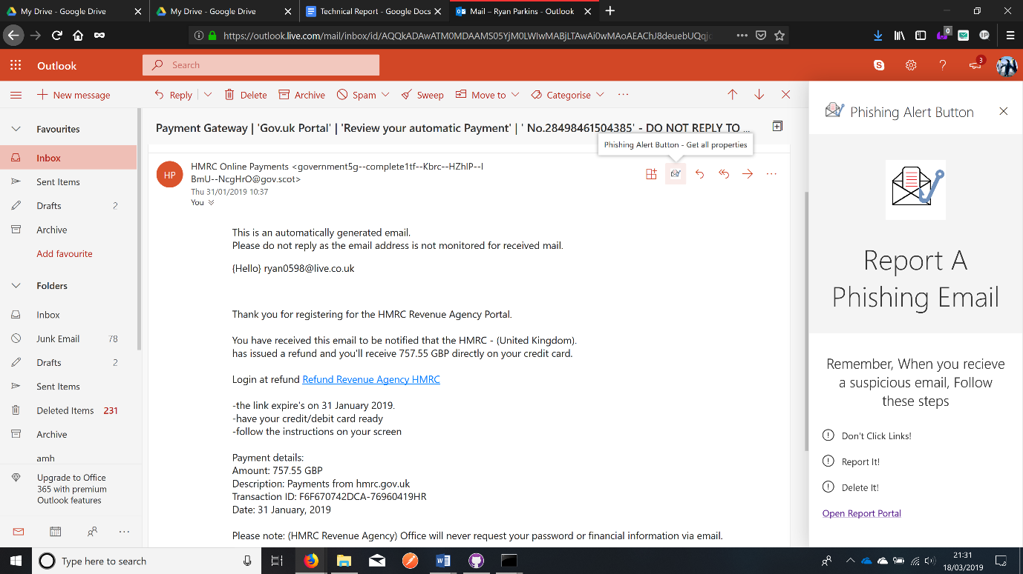

Figure 1 – Add-in appears inside of any email a user opens, click button to open screen, click “Open Report Portal” to open the site

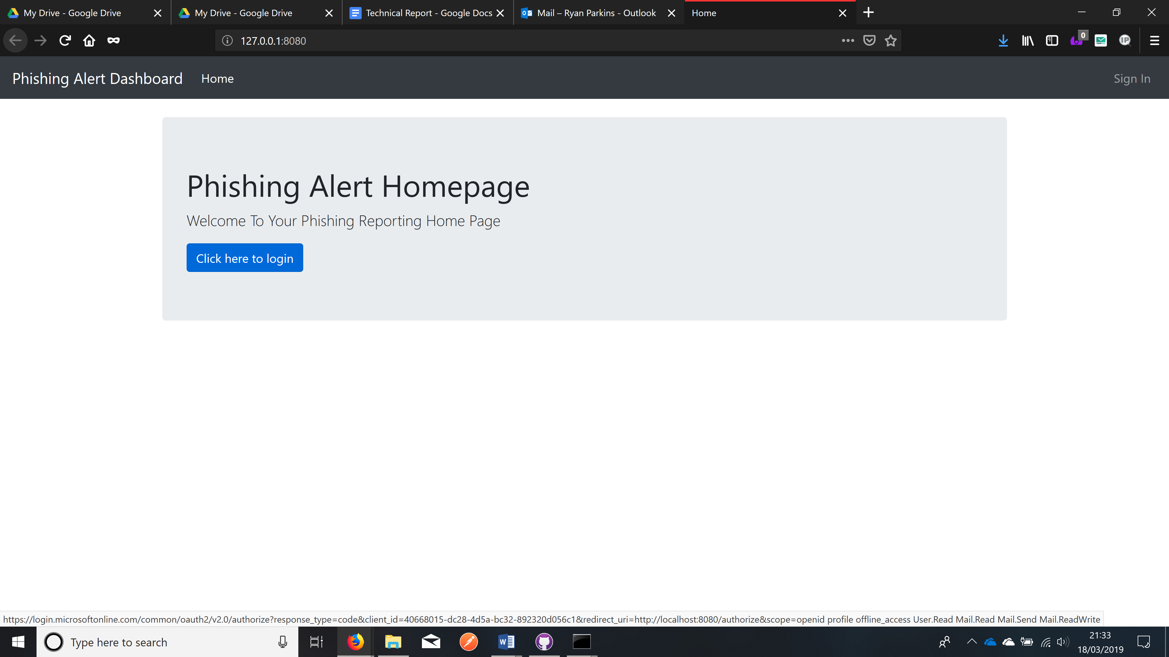

Figure 2 - Log-in to the site using Outlook credentials

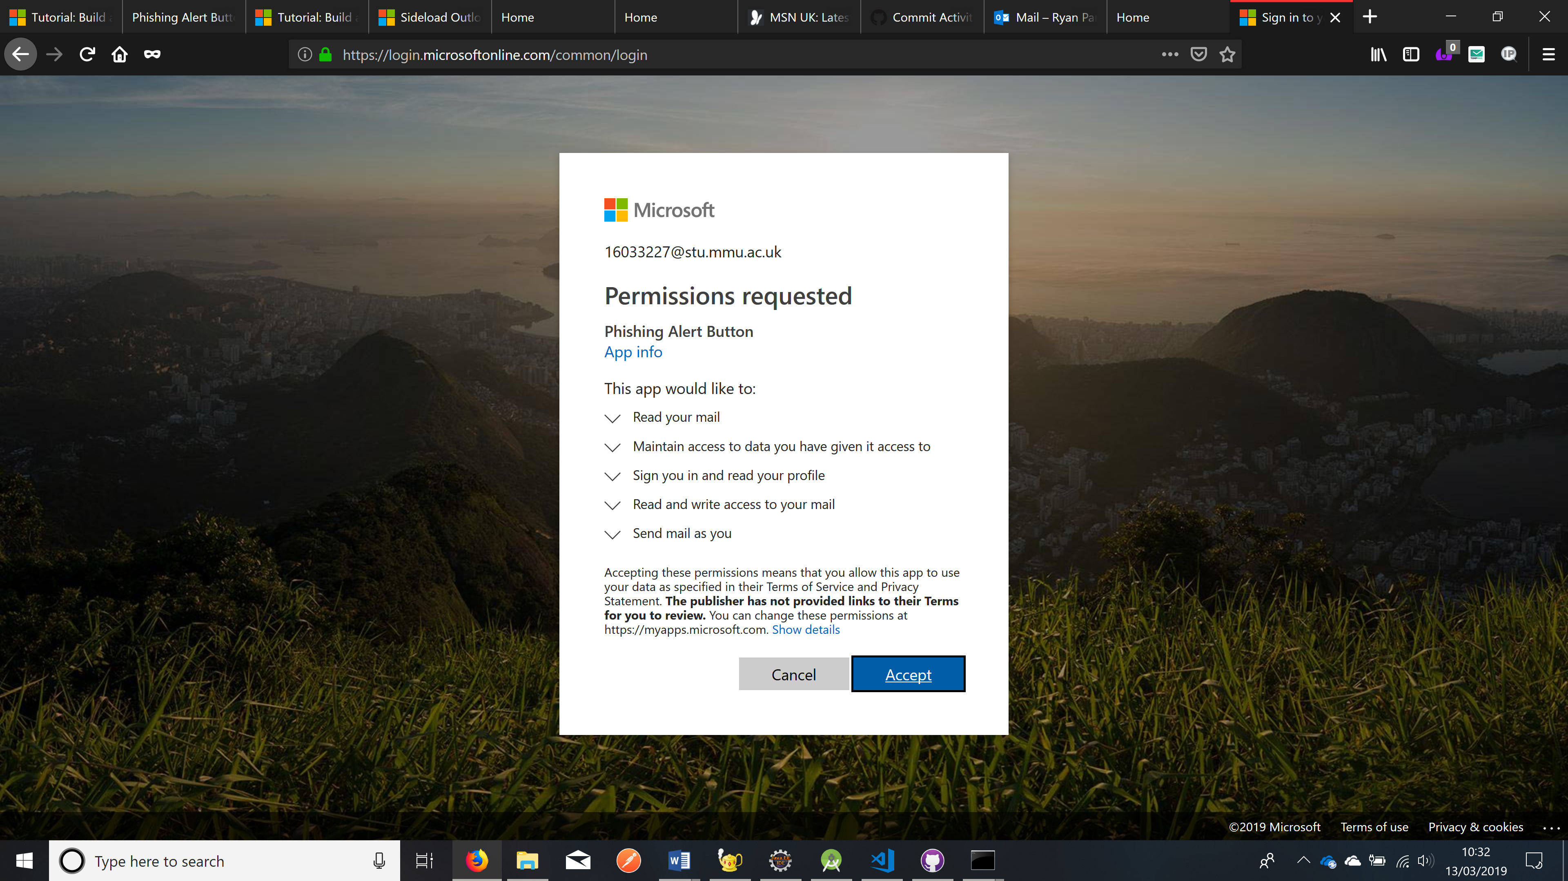

Figure 3 - Agree to permissions on first use

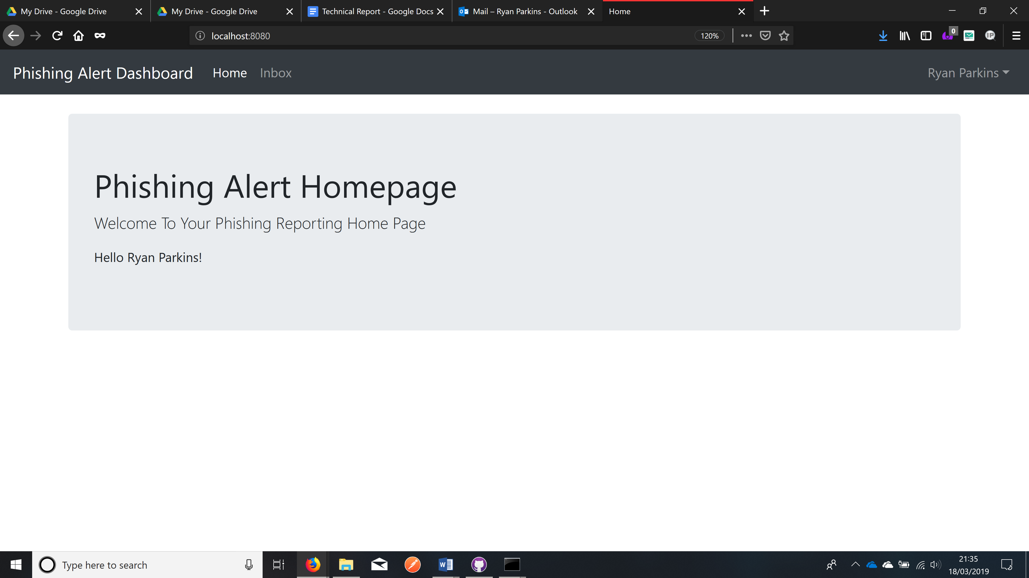

Figure 4 - Select Inbox to view emails

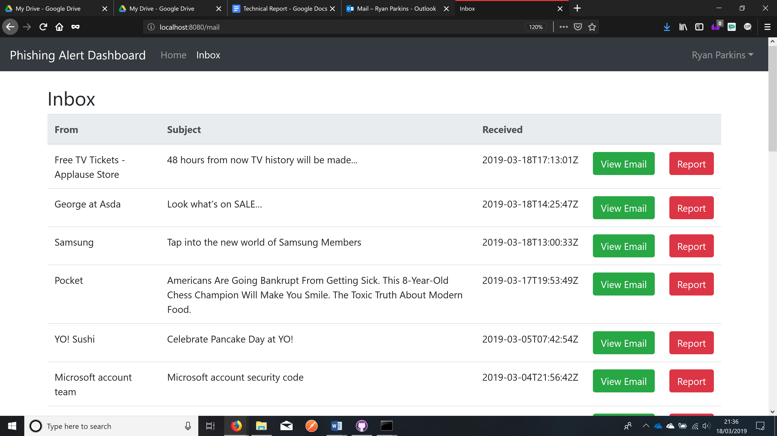

Figure 5 - See a list of emails from users inbox

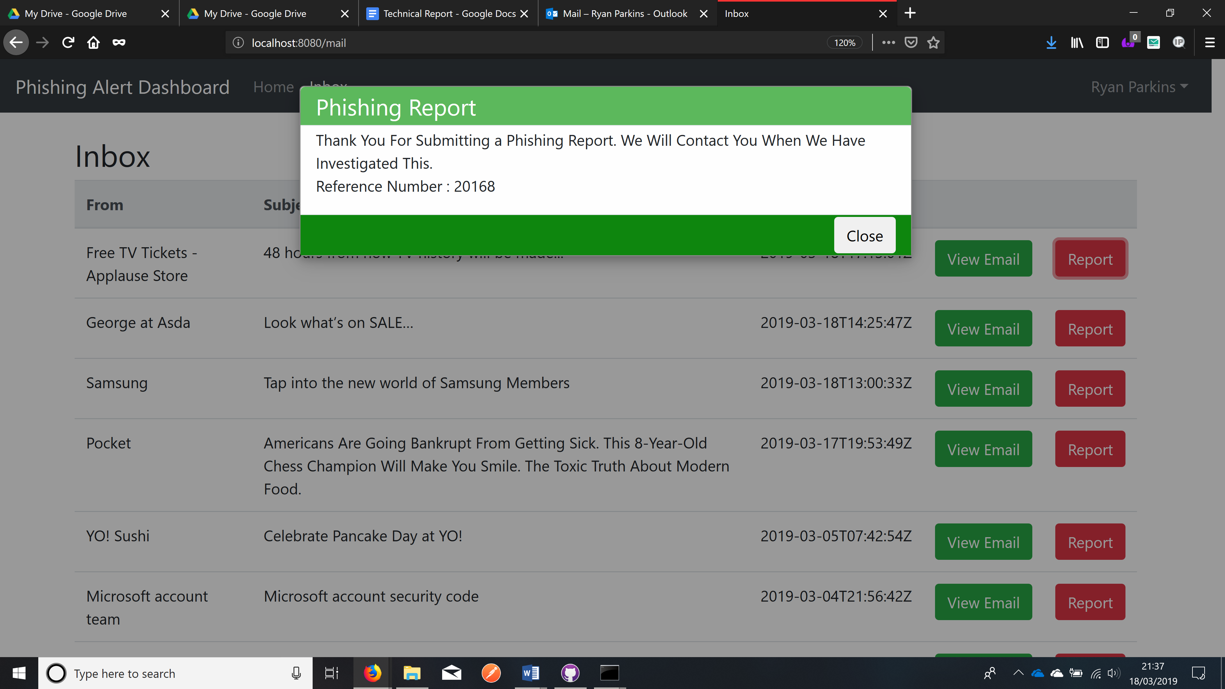

Figure 6 - Click "Report" to report an email

# Technical Handover Guide

## Languages / Formats Used Within This Project

* JavaScript
* XML
* HTML
* CSS
* HandleBars
* JSON
* ENV

## Build Process

The build process for this application was set out in two separate stages,

* Client based Button (Outlook Implemented)
* Client based webpage (On which reporting will be done)

The project was all coded inside of visual studio code, a guide on how to create add-ins similar to this button can be found at

* <https://docs.microsoft.com/en-us/outlook/add-ins/quick-start?tabs=visual-studio>.

The reporting web-side of the application includes OAuth2 authentication, creating cookies, session variables and API requests. A guide to how these featured can be implemented at the following.

* <https://docs.microsoft.com/en-us/previous-versions/office/office-365-api/api/version-2.0/mail-rest-operations>
* <https://docs.microsoft.com/en-us/outlook/rest/node-tutorial#implementing-oauth2>

## Current Source

The current code source can be found at the repository below

* <https://github.com/PhishingEmails/Phishing-Email-Button.git>

## Running And Implementing

The program is run via node.js and can be ran through the command prompt at this developmental stage.

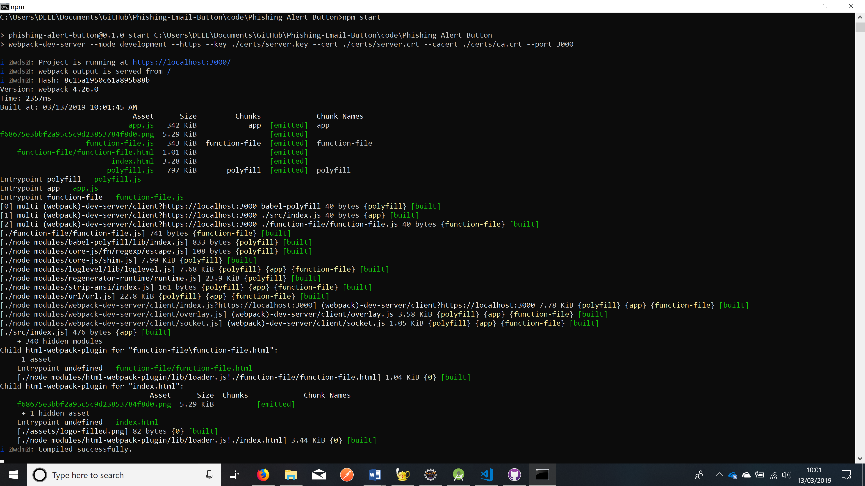

Figure 7 - Phishing Alert Button Outlook Add-In Server - Running On Localhost 3000

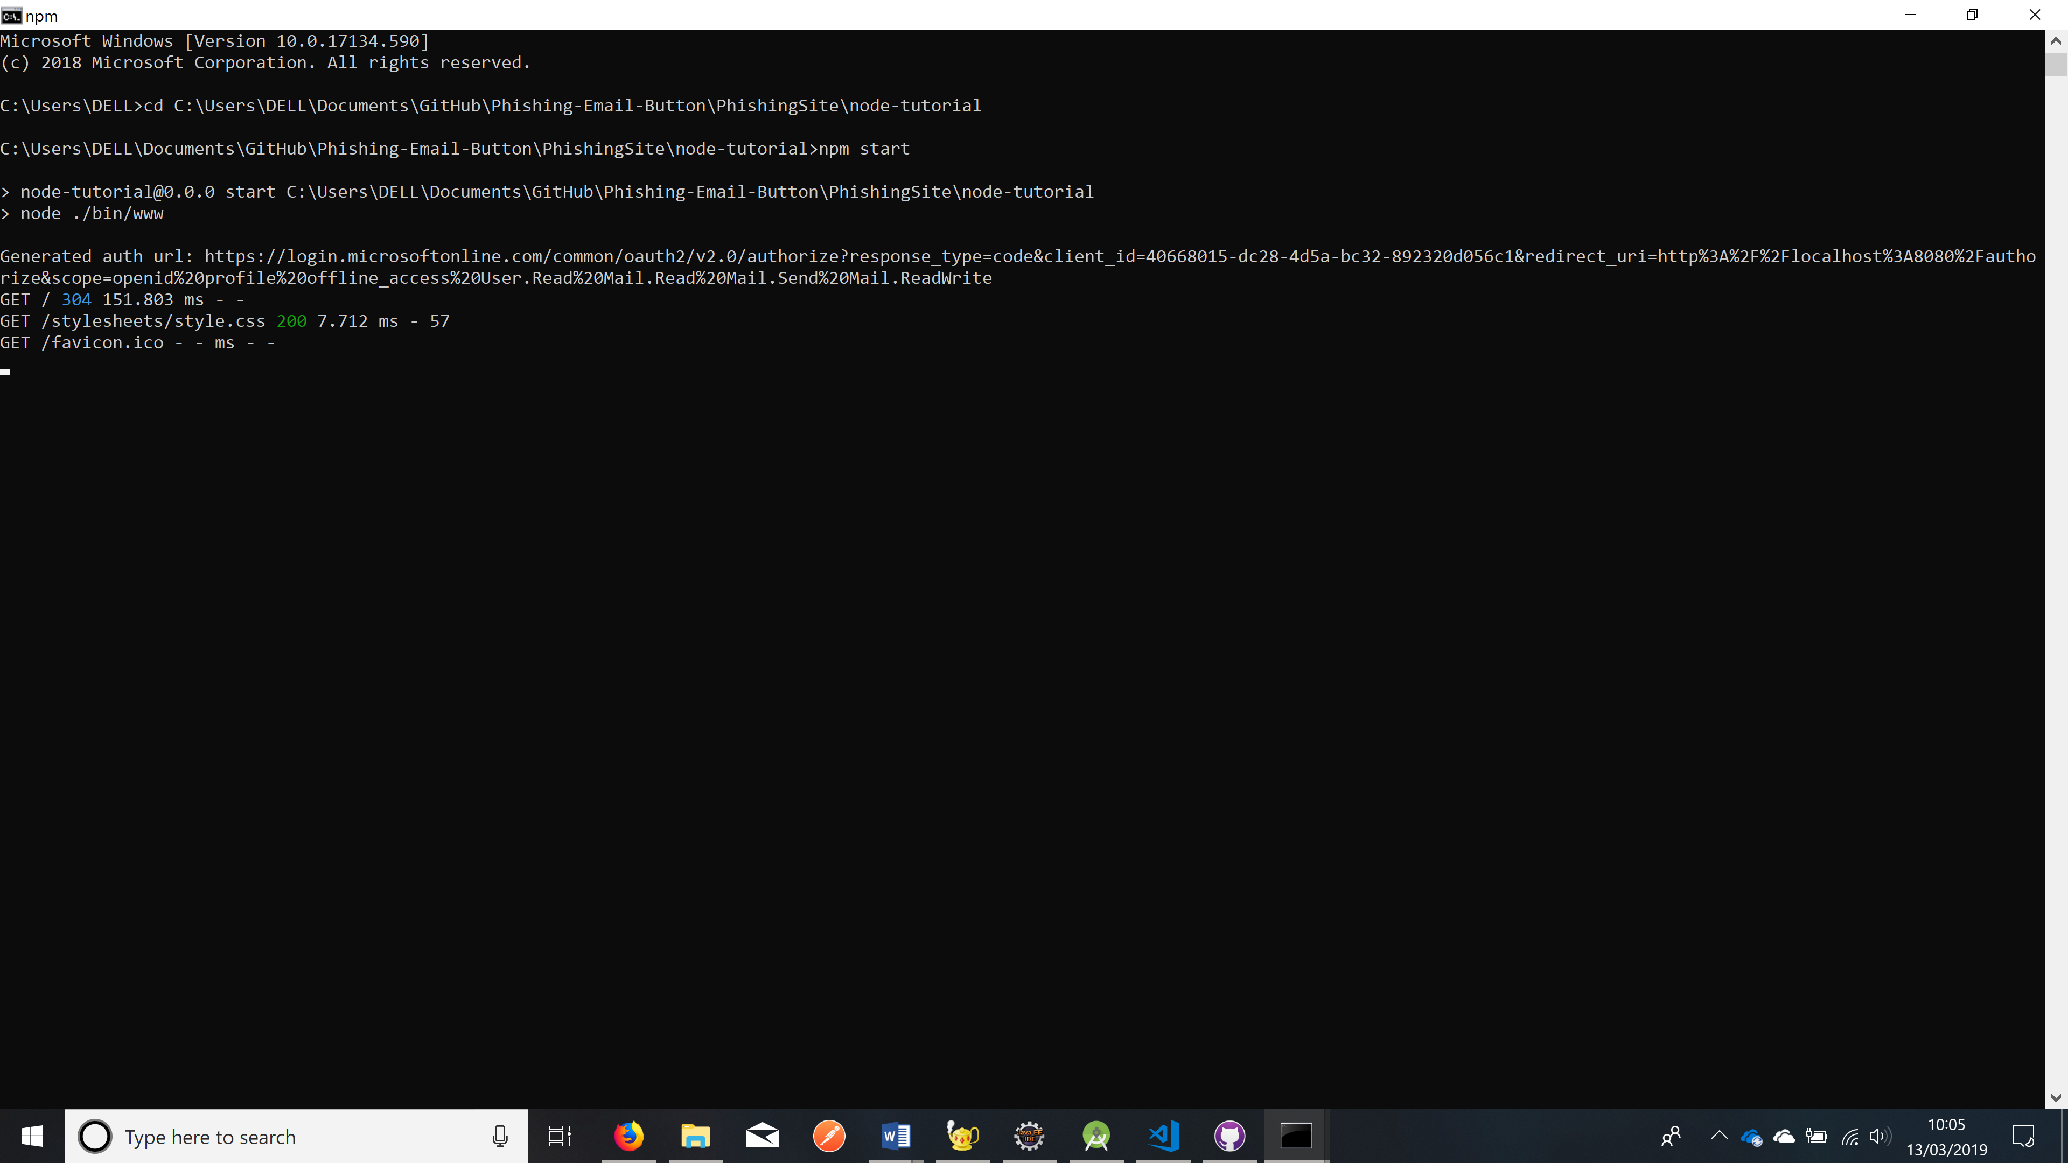

Figure 8 - Web Side - Running On Localhost 8080

Once both servers are running, You can add your add-in to the client email as follows:

* <https://docs.microsoft.com/en-us/outlook/add-ins/sideload-outlook-add-ins-for-testing>

# Conclusion

Phishing emails are more common than originally thought, the use of this button is crucial to combat phishing attacks. This button will be beneficial to businesses as they are vulnerable when it comes to targeted phishing attacks, losing extraordinary amounts of money each year.

During this project, there were limitations. One being; using a programming language never used before, this made progress slow due to having to learn a language from scratch.

When undertaking future projects like this one more people would be allocated to the technical side of the project, as having one member carry out all programming tasks made things difficult in terms of progress.

# References

Keepnet Labs Phishing Simulation Statistics 2017, 126.000 phishing tests. (2018) Anti Phishing Solution and Awareness Education. [Online] [Accessed on 10 February 2019]<https://www.keepnetlabs.com/phishing-statistics-2017/>

Lim, W. (2019) *A Beginner’s Guide to Wireframing*. Web Design Envato Tuts+. [Online] [Accessed on 5 March 2019] https://webdesign.tutsplus.com/articles/a-beginners-guide-to-wireframing--webdesign-7399.

# Appendices

All documentation relating to this project can be found in the repository below –

* <https://github.com/PhishingEmails/Phishing-Email-Button.git>